Nepal college of information echnology
Assessment
Semester Fall 2015
Level: Bachelor |  | Year : 2015
Programme: BE SE |  | Full Marks: 100
Course: Data Structure and Algorithm |  | Pass Marks: 45
 |  | Time : 3hrs.

Candidates are required to give their answers in their own words as far as practicable.
The figures in the margin indicate full marks.

Attempt all the questions.

 | - What is STACK? Define its primitive operations of STACK with Examples.  - Write an algorithm to evaluate an arithmetic expression in postfix string. Apply the algorithms to evaluate AB+C-DE-F*+G- where A=3,B=1,C=2,D=7,E=4,F=2 and G=5. | 7  8
 | - Differentiate between static list and dynamic list. Write an algorithm to insert an element in contiguous list.  - What are the advantages and disadvantages of linear linked list over array? What are the limitations of singly linked list? Can these limitations be overcome by use of circular linked list or doubly linked list? Explain with example. | 7  8
 | - Write a module function to insert and delete an item in the queue in circular representation.  - State the Tower of Hanoi (TOH) problems. Explain the recursive procedure to solve the TOH problems. | 8  7
 | - Construct an AVL tree from the given data  35,56,64,68,65,44,31,49,45,20,25. Also, explain the methods of balancing the AVL tree.  - What is expression tree? Determine the pre order, in order and post order traversal for the binary tree as overlaid.  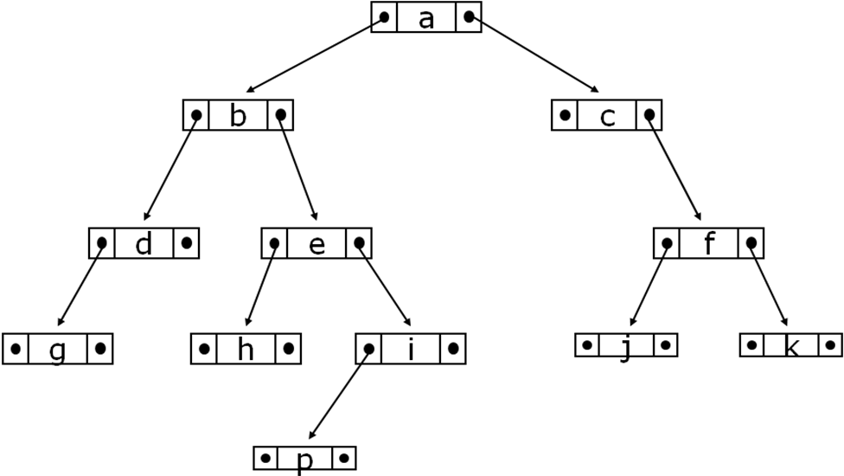 | 8  7
 | - Write algorithms for binary search technique and explain it with an example. When is the binary search technique useful?  - Trace quick sort algorithms for the following data:  98,58,57,12,18,73,150,210,56 | 7  8
 | - Define graph and diagraphs? Explain methods for representation of graph with examples.  - Explain Breadth First Search with an example. | 8  7
 | Write short notes on any two:  - Radix sort  - Quadratic Probing in hashing  - Warshall’s Algorithm  - Heap Sort | 2×5

